Nov. 6, 2014
Dear 5th grade parents/guardians:

Our next unit of study in Science is Genetics, Heredity and the Human Body. I am very excited to inform you of an upcoming opportunity your child has to further his/her knowledge for this unit. Through a company named Bio-Rad, I have been able to secure a real scientist to come and help your child extract his or her DNA. The best part is that your child will receive a necklace to store his/her DNA and be able to keep/wear forever!
The scientist will be coming to WPES to perform this demonstration with your child Friday, November 14th. This opportunity is absolutely free of charge to your child but will be priceless in educational value. If you would like more information on this program, please visit Bio-Rad’s website: https://isurvey.bio-rad.com/ scienceambassadors/welcome.action#.VFcf-ct0zIU
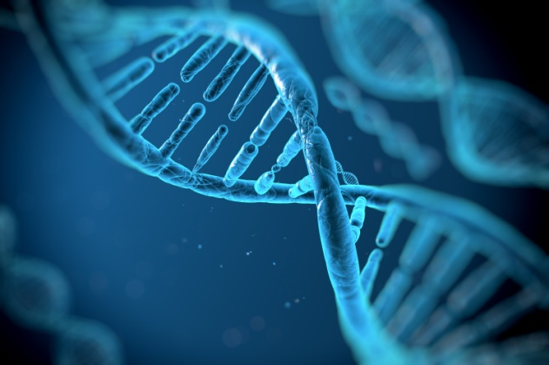
If you would like for your child to participate in this once-in-a-lifetime opportunity, please fill out the permission slip below and return it to me by Friday, Nov. 14, the day the scientist comes. If a permission slip is NOT returned, your child will NOT be able to extract and take home his/her own DNA. If you have questions, do not hesitate to contact me at michellel.beatty@cms.k12.nc.us. As always, thank you for your support in your child’s education.
Ms. Michelle Beatty

----------------------------------------------------(cut here)-----------------------------------------------------------------------------------
*Please check one. Have your child return this bottom portion to Ms. Beatty by Friday, November 14th.
_____ Yes, I would love for my child, __________________________________________, to be able to extract his/her own DNA with a real scientist and keep it forever!
(child’s name)
_____ No, I do not want my child, _____________________________________________, to extract his/her own DNA with a real scientist.
(child’s name)

Parent Signature ________________________________________ Date _______________

