An inherited trait is a characteristic a living thing possesses that is inherited from their parents.
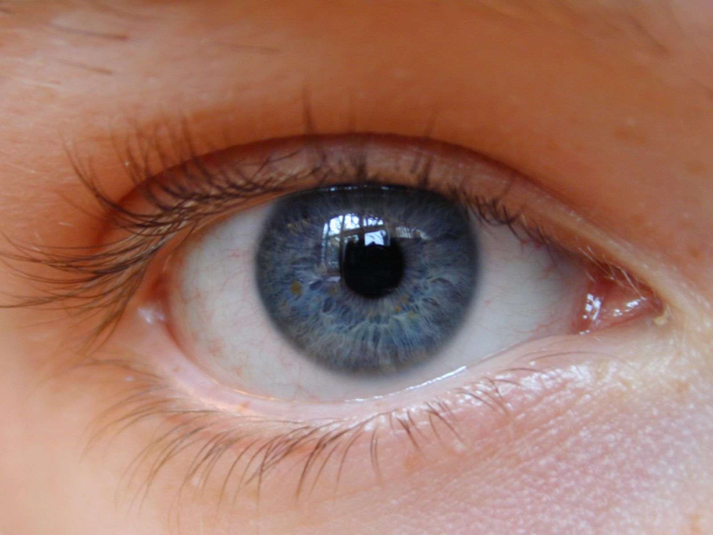

The color of a person’s eyes is an inherited trait. The color is a result of a person’s parents.

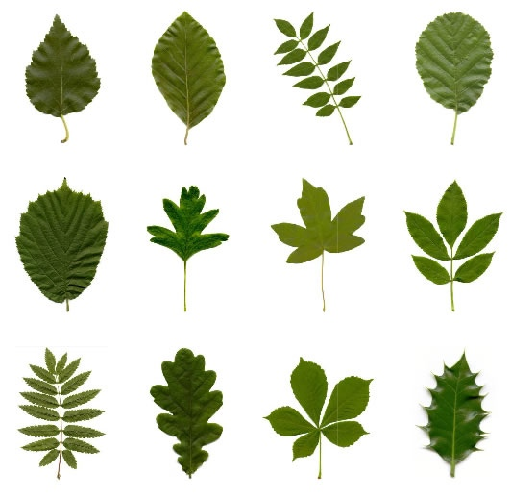

The shape of leaves on plants is an inherited trait. The shape depends on what is inherited from the parent plant.

Other examples of inherited traits:


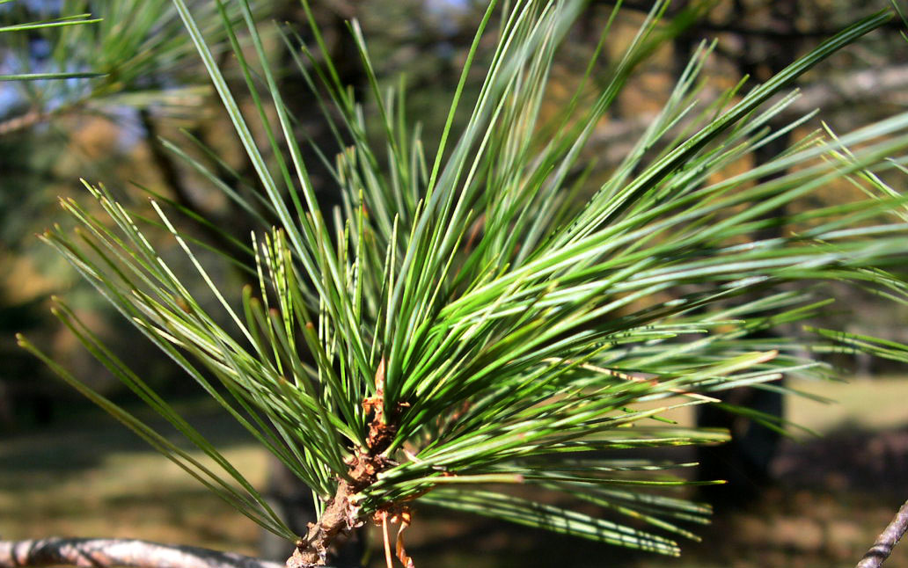
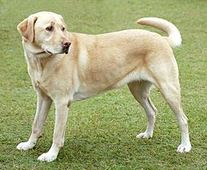
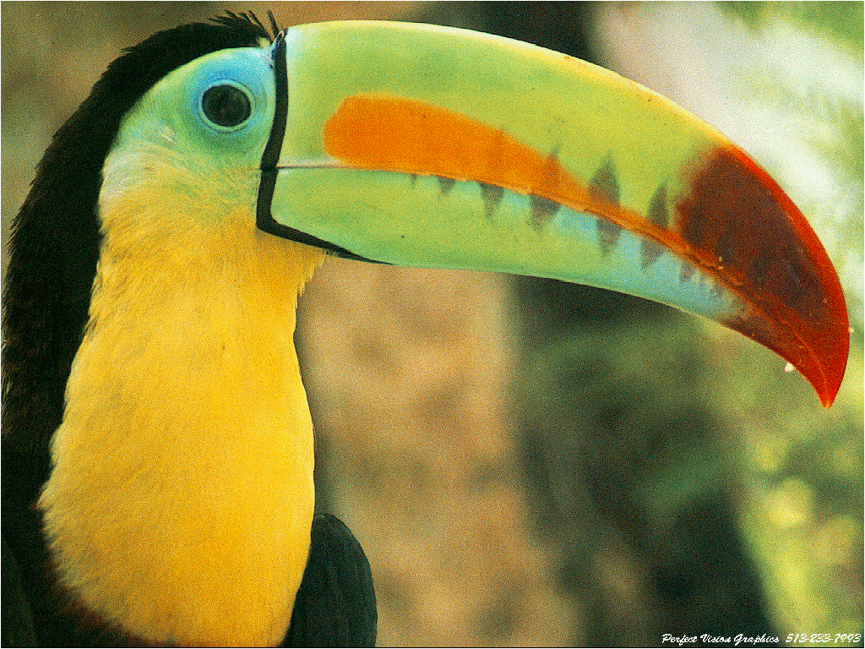
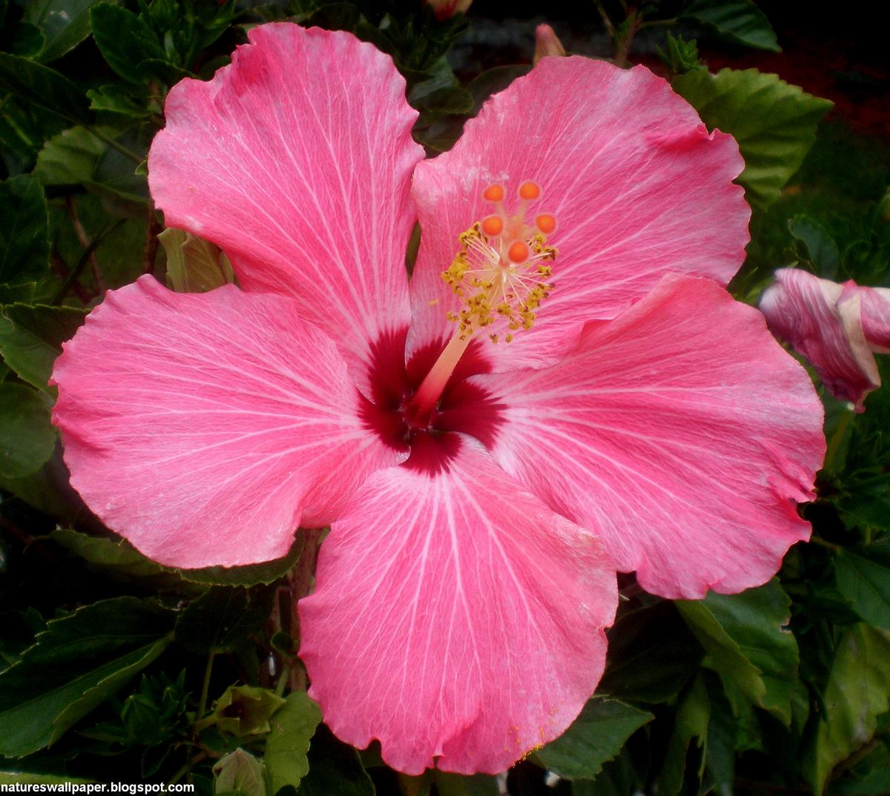
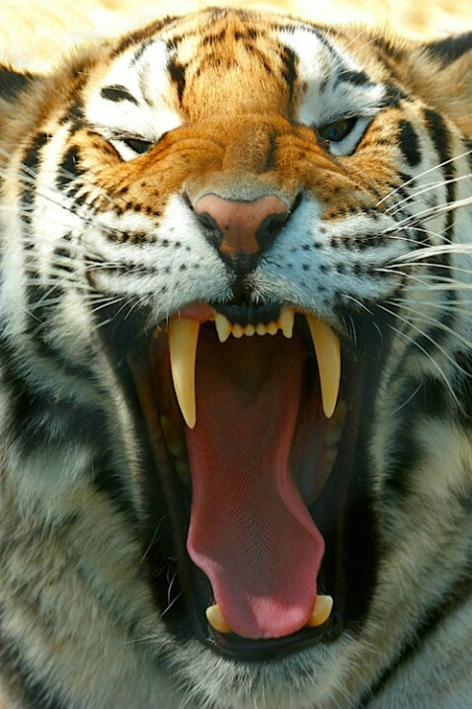
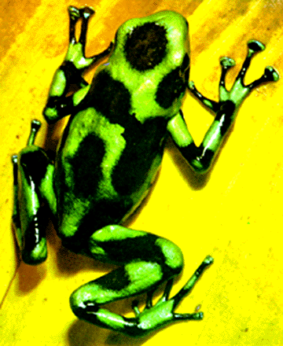

shape of nose
number of legs
color of flower
color of hair

shape of beak
shape of needles
shape of teeth
body markings

Some characteristics that animals, plants, and humans possess are not inherited from their parents. Instead, these characteristics are behaviors that are learned from the environment in which the organism lives in.
Check out the examples of learned, or acquired, behaviors below:

Reading a book was not something inherited from mom or dad. The girl learned how to read. Reading a book is a learned behavior.


The seal was not born knowing how to balance a ball on its nose. That skill did not come from the seal’s parents. The seal learned how to balance a ball on its nose. This is a learned behavior.


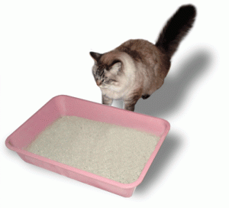


Other examples of learned behaviors:

playing baseball
cat using a litter box
writing
hairstyles

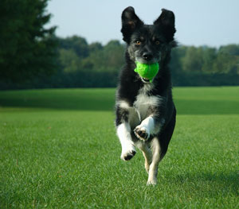



playing an instrument
dog fetching a ball
talking
typing

Activity 1: Your Inherited Traits

- Look at each inherited trait picture below and read its description.
- Use a mirror to determine if you display the trait or if you do not display the trait.
- Next to each inherited trait, check the box Yes if you do possess the trait or check the box No if you do not possess the trait.
- Compare your inherited traits to your other group members.
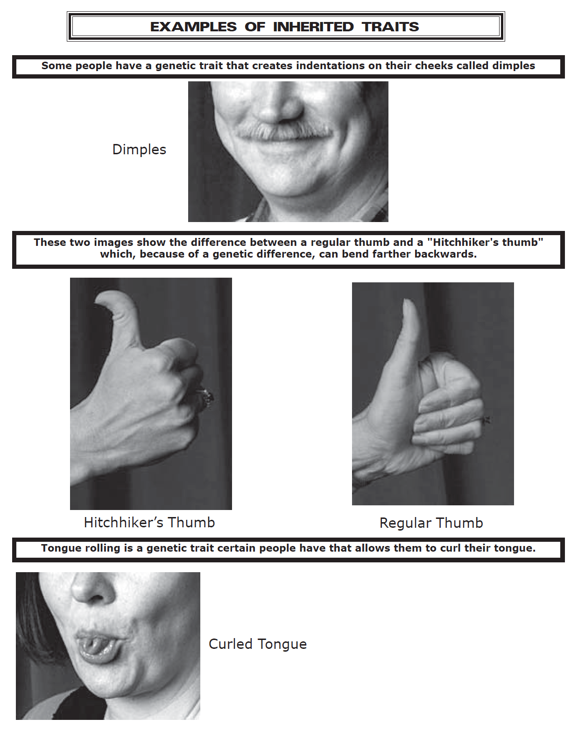

Do you have dimples?
YES NO

Do you have a hitchhiker’s thumb?

YES NO

Do you have a curled tongue?
YES NO

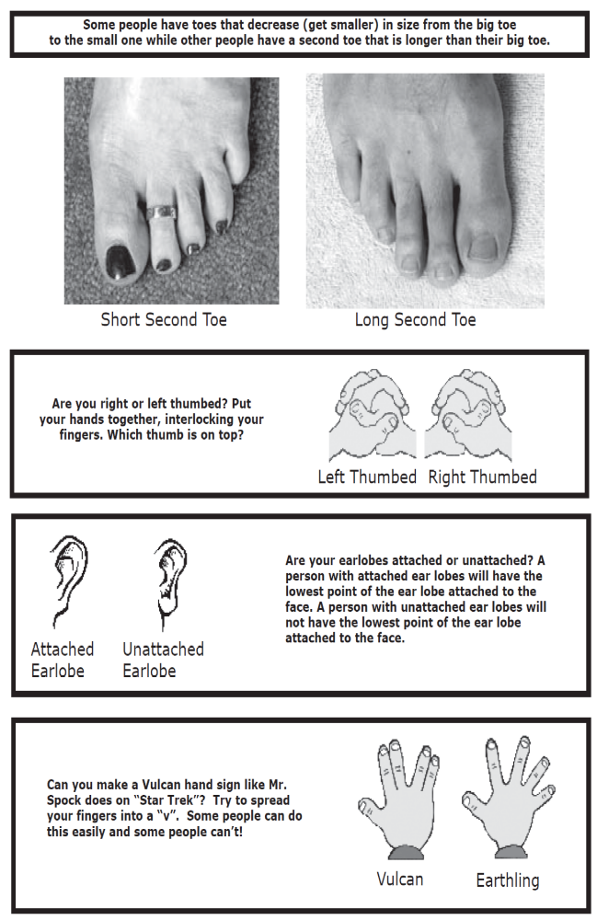
Do you have a long second toe?
YES NO

Are you right thumbed?

YES NO

Do you have attached earlobes?

YES NO

Can you make the Vulcan hand sign??

YES NO

List 5 more examples of inherited traits that you can think of:

Activity 2: Animal Traits
- Pick out one of the plastic animal figures to work with.

- Observe the animal. Think of the environment the animal lives in.

- In the diagram below, draw and label a picture of your animal in the middle circle.

- In each of the outer circles, write down an inherited trait the animal possesses. There are five circles so you must think of five inherited traits.

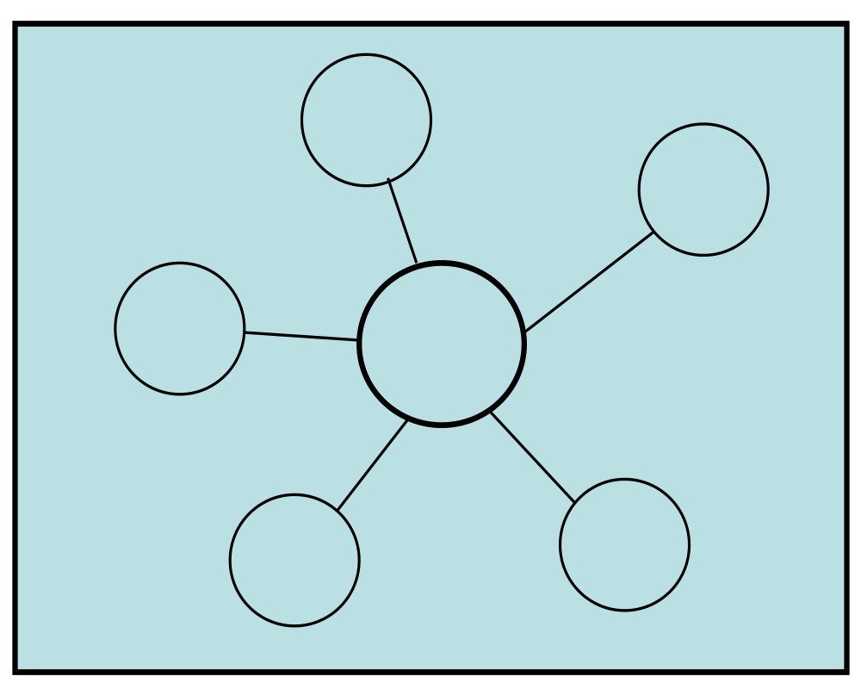

Activity 3: Inherited From Parents or Learned From Environment?

- Take out the folder with the cards inside of it.

- Read each card to determine if it is an example of an inherited trait or a learned behavior.

- Sort your cards into two piles: one for Inherited Traits and one for Learned Behaviors.

- Fill in the T-chart below by writing down the cards you put in the Inherited Traits pile and the Learned Behaviors pile.
Learned Behaviors
Inherited Traits

TEACHER COPY - Use with Activity 3
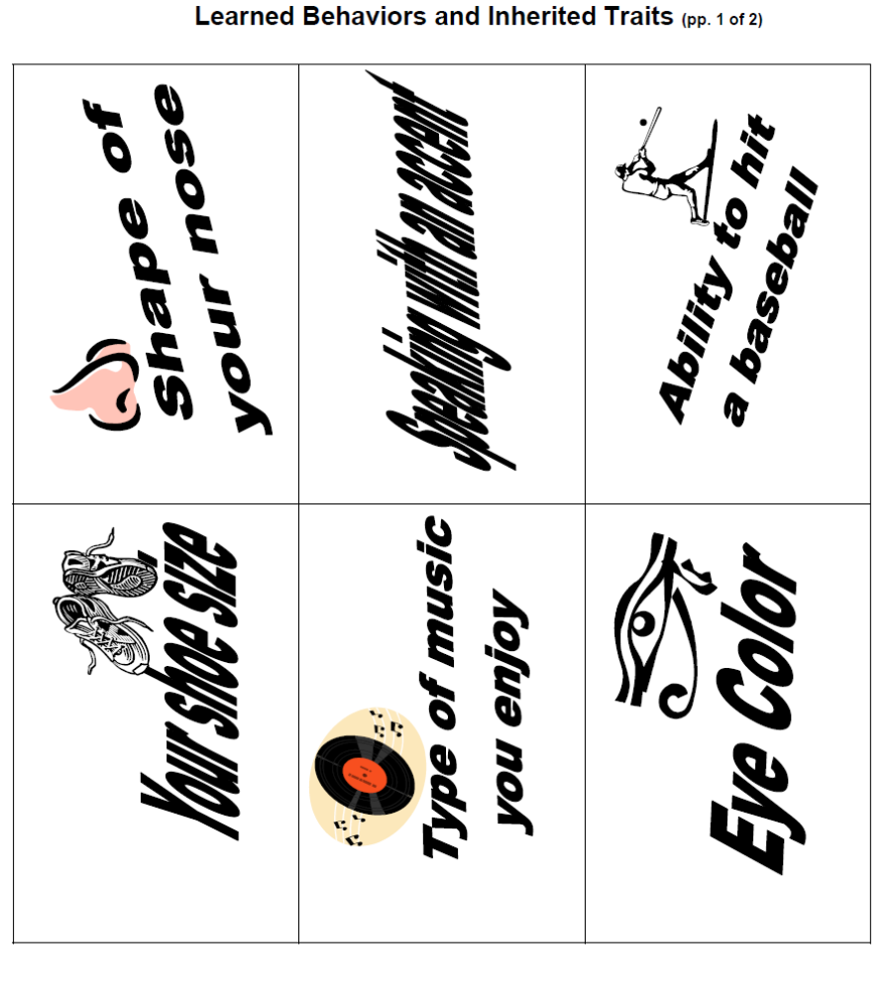

TEACHER COPY - Use with Activity 3
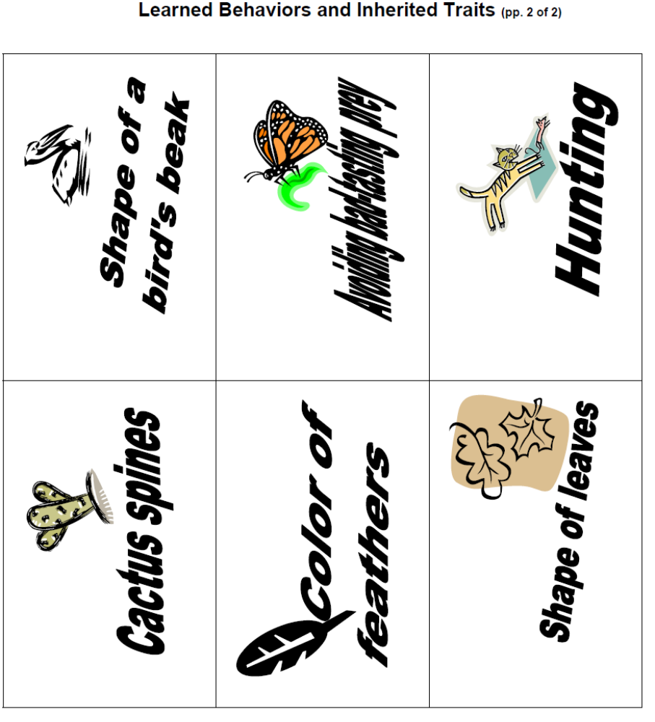

Activity 4 – Charades
1. Read directions below first before playing.
2. At your table, split students into two teams: Team A and Team B
3. Do not look at the cards.
4. Divide the cards in half. One team receives five cards, and the other team receives five cards.
5. Team A: You will select one of your cards. Talk to your partner about what action is on the card and how you will act it out to the other team. You will have 30 seconds to decide how you will act it out. While you are acting it out to the other team, no words may be used.
6. Team B: You will guess what action Team A is acting out. You have 30 seconds to make your final guess. Only one guess can be made. (Don’t keep shouting out several guesses; one is it!)
7. If team B guesses the correct action, they earn one point. Mark the one point in the chart below.
8. If team B guesses the incorrect action, no point is earned. Team A tells Team B what the action was they were acting out.
9. Team B has another chance to earn a point. Once the action is identified, Team B says aloud if the action is an example of an inherited trait or a learned behavior.
10. Team B: Once you have made your guess, check with your teacher to see if you were correct. If you get the answer correct, mark one point in the chart below.
11. Teams switch roles. Team A guesses and Team B acts out the action.
12. Remember to check with your teacher to see if answers are correct. Keep up with the score!

TEAM A | TEAM B

TEACHER COPY – Use with Activity 4
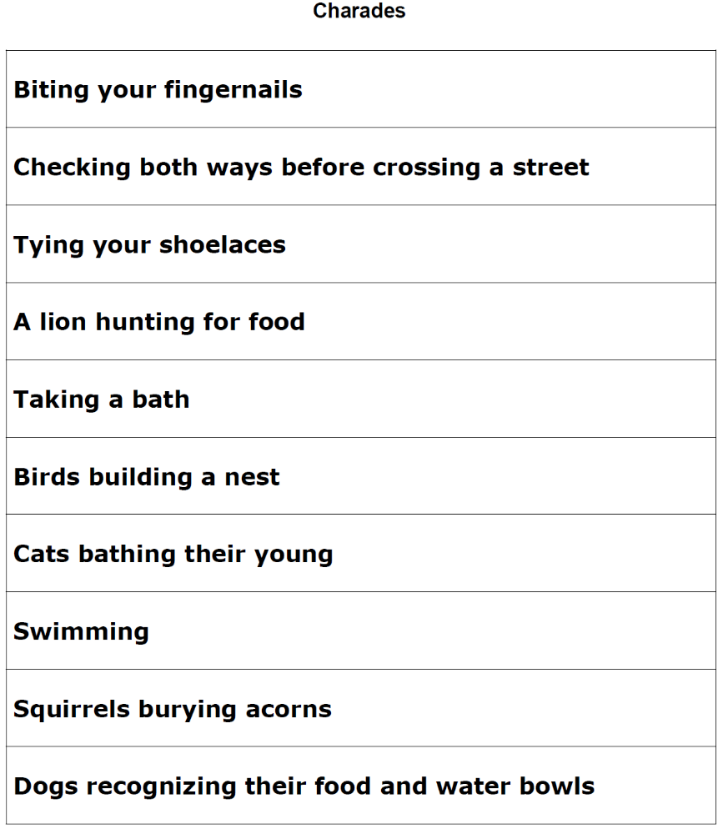

BONUS QUESTIONS
How are the behaviors that were acted out during Charades different from inherited traits? Are these behaviors inherited from parents? Explain your answer.

-------------------------------------------------------------------------------------------------------------------------------------------------------
BONUS QUESTIONS
Write your own definition for inherited traits. List 5 examples of inherited traits of a plant.

