STEM CHALLENGE
“Keep-a-Cube”

Objective: to construct a cooler that will keep an ice cube from melting for at least 30 min.

Teams: people at your table

Time to Build: 5 min. maximum

Materials:
- Shoe box or small cardboard box
- Ice cube
- Masking tape
- Wax paper
- Aluminum foil
- Newspaper or packing peanuts (may only use one)
--------------------------------------------------------------------------------
Team Members: ___________________ _____________________ _________________ _________________ _________________
We are in Science Block 1 2 3 Table Color: __________
Place a check mark next to the materials you plan on using:
√ shoe box or small cardboard box
_______________ will bring in a box by Thursday, April 23
√ ice cube
___ masking tape
___ wax paper
___ aluminum foil
Can use one or the other, but not both
___ newspaper
___ packing peanuts
Explain why your team chose each of the materials that you did in order to create your cooler.
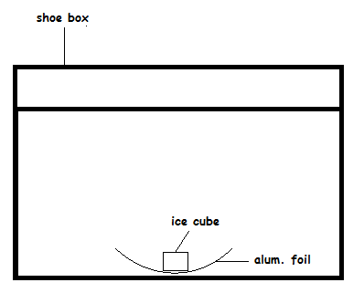
______________________________________________________________________________________________________________________________________________________________________________________________________________________________________________________________________________________________________________________________
Use the space below to draw a cross-section diagram of your cooler. Be sure to label each part of the cooler with the material that you are using for that part. Use the picture to the right to help you.
Keep-A-Cube Cooler Diagram

