Name______________________________________________________________# _________ HR _________________Sci. Block_________ Date ___________________
Measuring and Predicting Weather A and D Statements

Statement | My Thoughts | Statement | My Thoughts
1. A thermometer measures air temperature.  _____ agree  _____ disagree  _____ it depends |  | 7. If it is warm and sunny, most likely, evaporation is going on.  _____ agree  _____ disagree  _____ it depends
2. A rain gauge measures rainfall by collecting raindrops in a container.  _____ agree  _____ disagree  _____ it depends |  | 8. Cooler temperatures cause condensation.  _____ agree  _____ disagree  _____ it depends
3. An anemometer measures wind direction.  _____ agree  _____ disagree  _____ it depends |  | 9. Most of the water in the water cycle can be found in clouds.  _____ agree  _____ disagree  _____ it depends
4. Falling barometric pressure means rainy weather is approaching.  _____ agree  _____ disagree  _____ it depends |  | 10. Clouds that are scattered are less likely to produce precipitation.  _____ agree  _____ disagree  _____ it depends
5. In the water cycle, water changes from one state of matter to another.  _____ agree  _____ disagree  _____ it depends |  | 11. White puffy clouds are called stratus.  _____ agree  _____ disagree  _____ it depends
6. Transpiration is caused when plants release water from their leaves.  _____ agree  _____ disagree  _____ it depends |  | 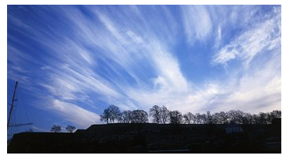  12. Skies like this mean rainy weather is coming.  _____ agree  _____ disagree  _____ it depends
Statement | My Thoughts | Statement | My Thoughts
13. In this picture, it is summer in the southern hemisphere.  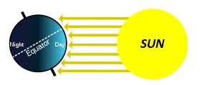  _____ agree  _____ disagree  _____ it depends |  | 18. Prevailing Westerlies are narrow, fast-flowing currents of air between 3 – 7 miles above Earth’s surface.  _____ agree  _____ disagree  _____ it depends
14. When it is becoming more hot and dry, fall is starting and summer is ending in the Northern Hemisphere.  _____ agree  _____ disagree  _____ it depends |  | 19. Ocean currents, like the Gulf Stream, affect weather on land.  _____ agree  _____ disagree  _____ it depends
15. Movement of air across the planet creates global weather patterns.  _____ agree  _____ disagree  _____ it depends |  | 20. The Earth's air and oceans are generally warmer near the poles and cooler near the equator.  _____ agree  _____ disagree  _____ it depends
16. As a result of the movement of the air in the Jet stream, weather patterns in the United States move west to east.  _____ agree  _____ disagree  _____ it depends |  | 21. A hurricane is caused by strong winds and warm air over the ocean.  _____ agree  _____ disagree  _____ it depends
17. When a polar air mass moves south toward the equator, temperatures will drop for that area.  _____ agree  _____ disagree  _____ it depends |  | 22. A scientist could predict local and global weather events by observing local and global weather patterns.  _____ agree  _____ disagree  _____ it depends

